Become Involved - How Can I Help?

Name:

Address:

City/Province: Pcode:

Phone: E-mail:

Manpower for Sportsman Shows

 Instructor for Conservation and Hunter Education Courses

Instructor for Fishing Education Courses

Instructor for Canadian Firearms Safety Courses

Contributions (products) for Youth Hunter Kits

Contributions (products) for Women’s Hunter Kits

Door Prizes for various events

Delivery and set up of Fact Sheet Display Holders

Copy editing

Writing and distributing News articles

Assembling Kits for special events, etc

Mail outs of information packages

Web-site Enhancements

Mentorship Programs – Serving as a Mentor

Access for hunting Initiatives?

Sales of products for fund-raising efforts

Other (Please specify):

#87, 4003 – 98th Street
Edmonton, AB
T6E 6M8
Phone: (780) 462-2444
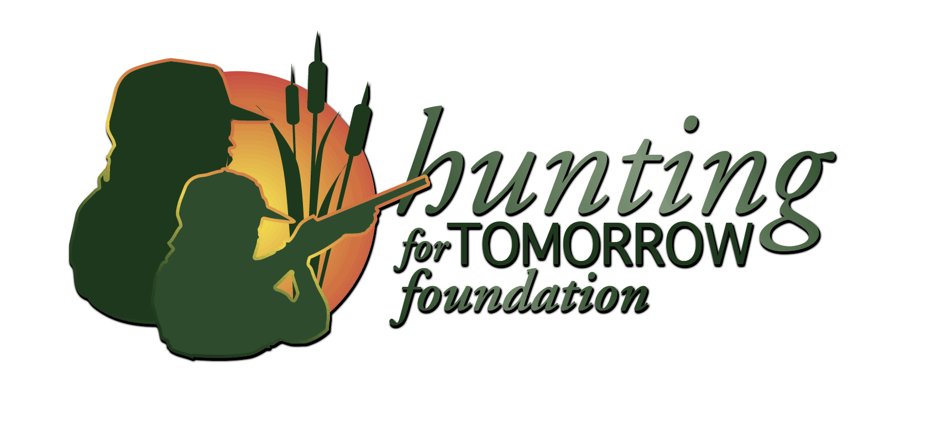Fax: (780) 431-2871
Kelly Semple, Executive Director
#87, 4003 – 98th Street
Edmonton, AB T6E 6M8
Phone: (780) 462-2444 Fax: (780) 431-2871
E-mail: ksemple@huntingfortomorrow.com
www.huntingfortomorrow.com

